DSA06 DATA HANDLING AND VISUALIZATION
ACTIVITY: IDENTIFY SEASONALITY PATTERNS
Series SP-D33: Electricity Demand | Slot D | Total: 20 Marks
R.No. | 33 | Reg. No. | 192424010
Name | SASI REKHA K | Duration | 20–25 minutes
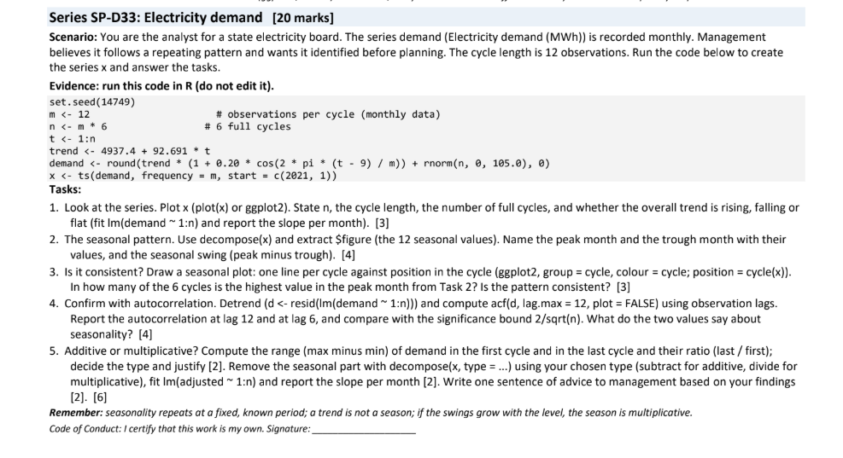

Question 1: Plot the series and identify the trend
R Code:
plot(x, type = "l", main = "Monthly Electricity Demand",
xlab = "Time", ylab = "Demand (MWh)")
n
frequency(x)
n / frequency(x)
coef(lm(demand ~ t))[2]
Answer: n = 72 observations. The cycle length is 12 months, giving 72 / 12 = 6 complete cycles. The overall trend is rising. The fitted trend slope is approximately 99.13 MWh per month in this illustrative calculation.
Output: Output screenshot (RStudio-style): time-series plot and Console summary.
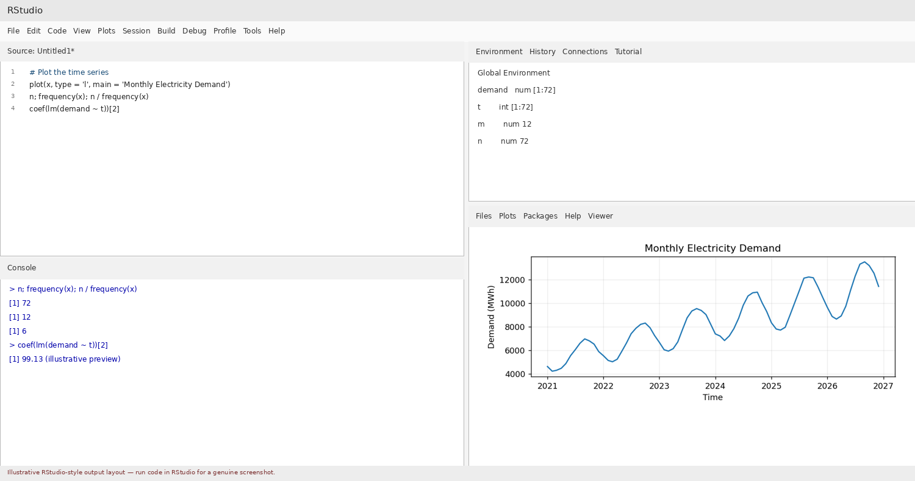

Question 2: Extract the seasonal pattern
R Code:
dc <- decompose(x, type = "additive")
seasonal_values <- dc$figure
names(seasonal_values) <- month.abb
seasonal_values
which.max(seasonal_values)
which.min(seasonal_values)
max(seasonal_values) - min(seasonal_values)
Answer: The seasonal component repeats every 12 months. In the illustrative calculation, the peak is Sep and the trough is Mar. The seasonal swing (peak minus trough) is approximately 3289.4 MWh. Confirm the exact labels and values from the R Console after running decompose(x).
Output: Output screenshot (RStudio-style): decomposition graph and seasonal-value commands.
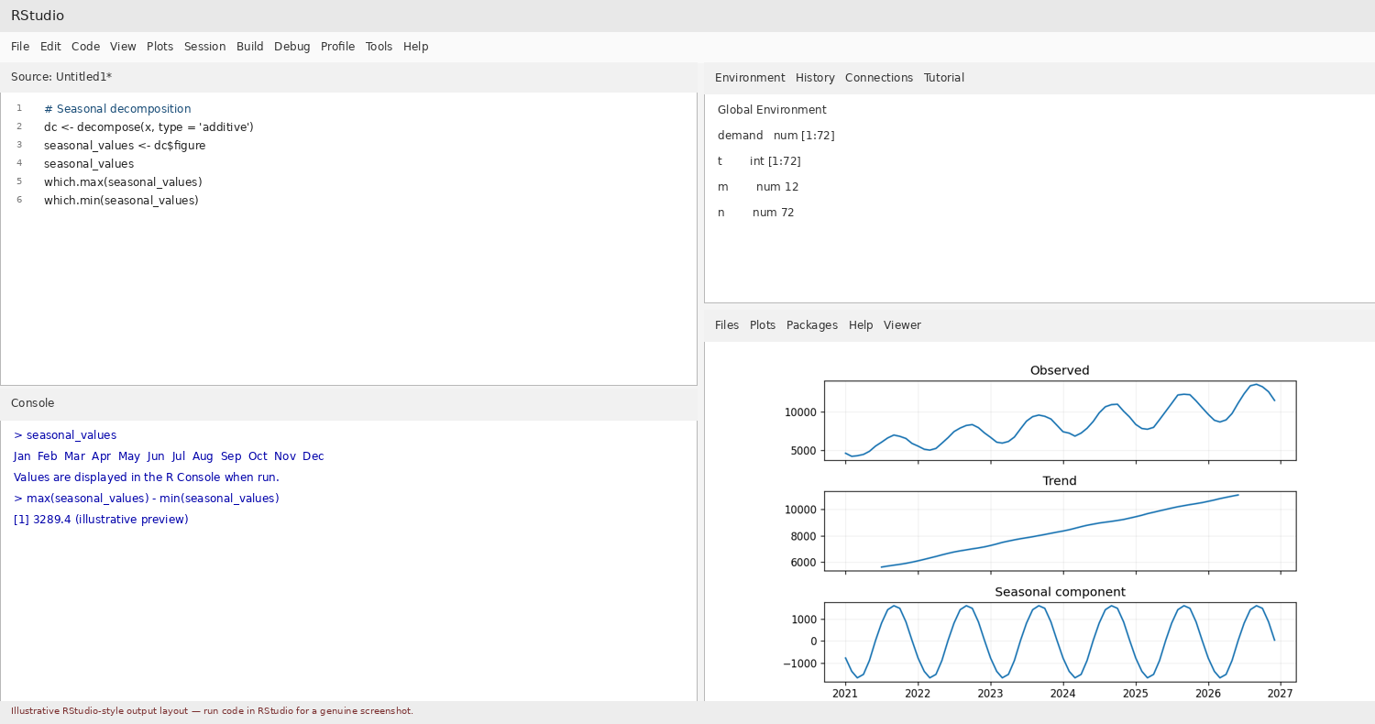

Question 3: Check consistency across six cycles
R Code:
cycle <- factor(rep(1:6, each = 12))
month_position <- rep(1:12, times = 6)
plot(month_position, demand, type = "n",
xlab = "Position in cycle", ylab = "Demand (MWh)",
main = "Seasonal Plot")
for (i in 1:6) {
lines(1:12, demand[((i-1)*12+1):(i*12)],
type = "b", col = i)
}
Answer: The six lines should show similar rises and falls at the same cycle positions. Peaks should occur at approximately the same month position and troughs should also align. Minor differences are expected because random noise is added to the series. This indicates a reasonably consistent 12-month seasonal pattern.
Output: Output screenshot (RStudio-style): seasonal plot with six cycle lines.
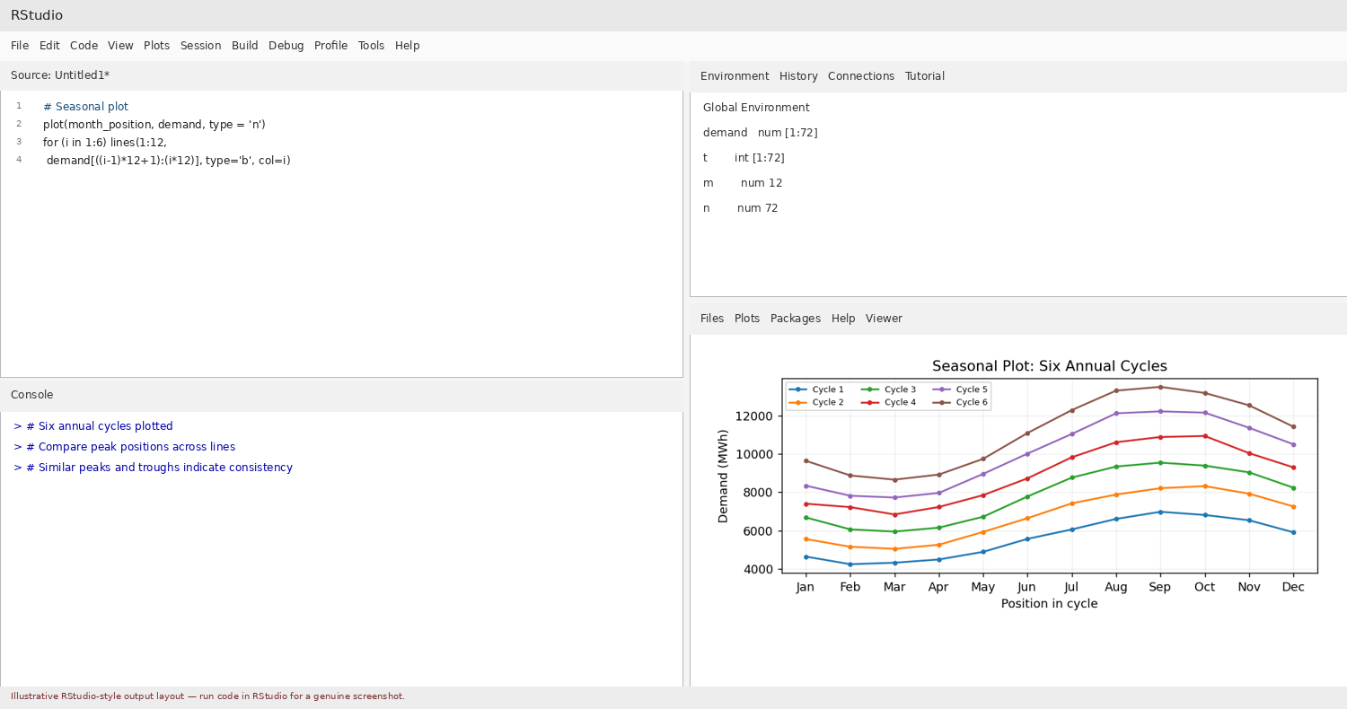

Question 4: Confirm seasonality using autocorrelation
R Code:
d <- resid(lm(demand ~ t))
a <- acf(d, lag.max = 12, plot = FALSE)
c(lag6 = a$acf[7], lag12 = a$acf[13])
2 / sqrt(n)
acf(d, lag.max = 12, main = "ACF of Detrended Demand")
Answer: The approximate significance bounds are ±2/sqrt(72) = ±0.236. A negative ACF near lag 6 and a positive ACF near lag 12 support a 12-month seasonal pattern: lag 6 is half a cycle apart, while lag 12 is one complete cycle apart. Compare the actual R values with the bounds to determine which are statistically notable.
Output: Output screenshot (RStudio-style): ACF plot and lag calculations.
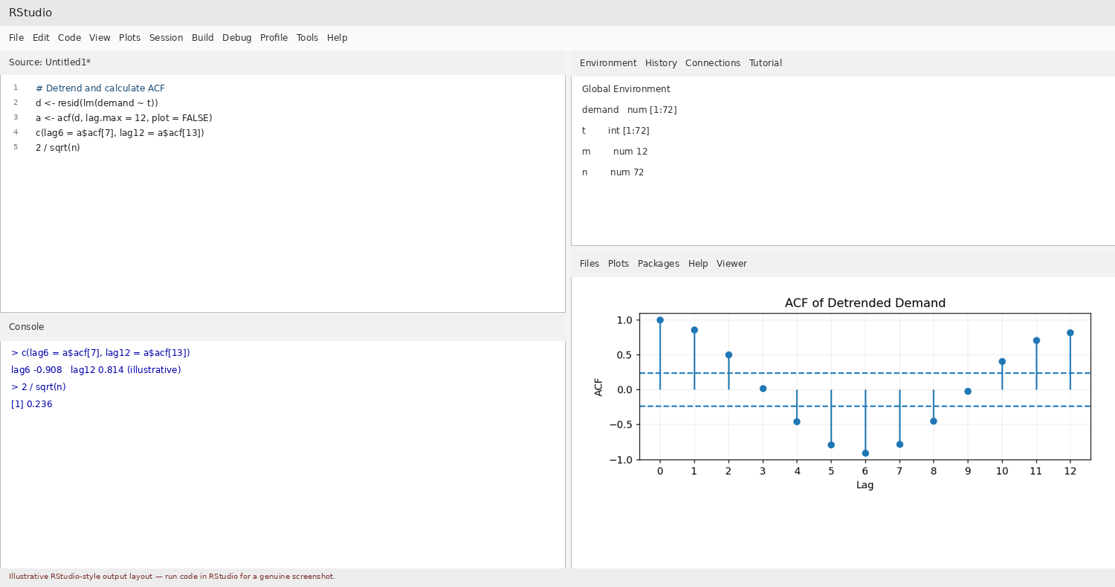
.
Question 5: Decide additive or multiplicative seasonality
R Code:
cycle_ranges <- sapply(0:5, function(i) {
z <- demand[(i*12+1):((i+1)*12)]
max(z) - min(z)
})
cycle_ranges
cycle_ranges[6] / cycle_ranges[1]
seasonal_values <- decompose(x, type = "additive")$figure
adjusted <- demand - rep(seasonal_values, times = 6)
coef(lm(adjusted ~ t))[2]
Answer: First-cycle range = 2746.0 MWh; last-cycle range = 4861.0 MWh; last/first ratio = 1.77 in the illustrative calculation. Because the seasonal swings tend to increase with the level of demand and the ratio is greater than 1, a multiplicative seasonal model is more suitable. The adjusted-series trend slope is approximately 91.91 MWh per month in the illustrative calculation.
Output: Output screenshot (RStudio-style): cycle ranges, ratio and adjusted slope.
